Contact Us Today:
CaptainBill@Starboardbeam.com
or call:
240-401-4464
Or
301-948-5333
Visit our websites at:
www.SailingVentures.biz
DreamCatcherSailing.
www.Starboardbeam.com

Phone: 240-401-4464

Take I-495 East to US-50 East via Exit 19A towards Annapolis, Maryland. Proceed 11.3 miles to Maryland State Route 424 via Exit 16 towards Davidsonville, Maryland. Go 3.6 miles to Central Avenue / Maryland State Route 214 East, turn east, go 7.3 Miles to CARRS WHARF Road and turn right. Note the Post Office on your right and Mayo Elementary School on your left at the intersection. Proceed to the 3rd right, CALAWASSE Road where you will turn right and go 1/10 of mile to 3922 CALAWASSE, entrance on left.
Or
Take the Capital Beltway to Central Avenue (Maryland State Route 214) and continue east on to Mayo, Maryland. Proceed as directed above.
You will find Dream Catcher to the left facing the water at the end of Pier 3 in berth 23. Get Lost? Call us at: 240-401-4464

Directions to Holiday Hill Marina

Port-o-Call for Sailing Vessel “Dream Catcher”

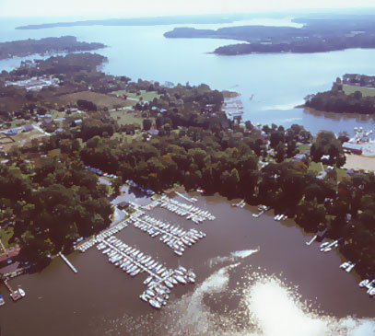
MainSail Charters & Research, LLC

www.SailingVentures.biz
www.Starboardbeam.com
DreamCatcherSailing.biz
240-401-4464

2

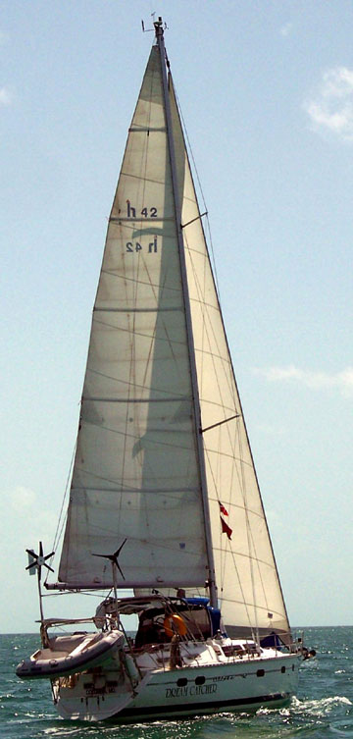
In less than an Hour from the Washington D.C area, YOU can be on a Sailing Charter or Learning to Sail on the beautiful Chesapeake Bay
MainSail Charters & Research, LLC offers sailing adventures and learning experiences for the novice or experienced on the Chesapeake Bay leaving from Holiday Hill Marina on the Rhode River, Mayo, Maryland.
4, 6 and 8 hour charters are available at reasonable rates.
Bookings available Weekdays and Weekends

Main Sail Charters and Research, LLC

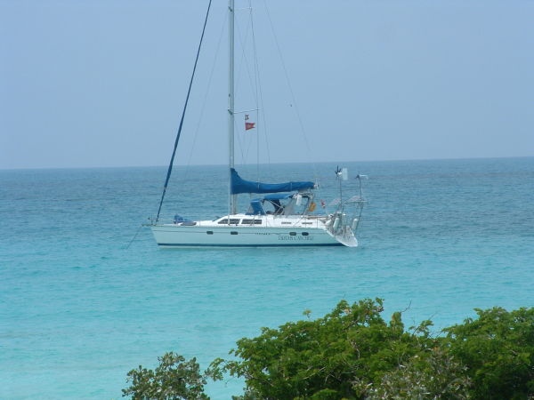

Have you just gone out and on a whim bought a new or used sailboat because it looked to be fun and enticing? Have you just realized you know nothing about sailing? Have you just realized you need help?
MainSail Charters Instructors will work with you to arrange and provide you with instruction on you’re newly purchased Sailboat. You learn as you gain confidence and knowledge of your boat, how it sails and how it feels underway.

Learn Sailing on DreamCatcher – a Hunter Passage 42 or On Your Own Boat
Our Captains will provide you with instruction using our “Introduction to Sailing” instruction package; or working with you, “Your Personal Boat Instruction” course will be developed to provide you with a course of sailing instruction that is best suited for your particular need. Individual specialized courses may be either on your boat or aboard DreamCatcher,
Sailed on small boats, but never on a larger boat? Then our “WOW ! ! That’s a Big Boat” course is for you. Learn larger boat sailing and handling skills.
If you want to learn to figure out where you are or where you are going, our Navigation instruction may be just for you.

MainSail Charters & Research, LLC
RATES:
INSTRUCTION
“Your Personal Boat Instruction” : $100.00 per hour
“WOW! That’s a Big Boat” : 2 days - $450 per person. Discounts of $50.00 per person if two sign up together and $75.00 discount per person if 3 sign up together.
Maximum of 6 students per class
CHARTERS
$100.00 / hr – 3 hour minimum
Military, Law Enforcement, EMS Discount
(Maximum of 6 individuals)
Ice and Water provided – Charterers may bring their own meals or snacks
Lunch Stops can be arranged.
Sunset Cruises
Weekday or Weekend Evenings –
5-8 p.m.

Fall Leaf Watching -late September through October

CHECK OUR WEBSITES FOR A FULL LIST OF COURSES AND RATES

*******************************
Special Discounts
Group Discounts on Day Charters and lessons
$50 Discount on Day Charters & Sailing Lessons To: Active Military, EMS, and Law Enforcement Personnel
*********************************
All boat Captains are United States Coast Guard Licensed

CHARTER DISCLAIMER: A Note to those who may want to Charter: We sail based on where the wind originates. Preferred destinations may not always be reached though we will make all attempts within reason to get to where you want to go in the time allotted.

We will stop to swim if you wish though all in the water will wear USCG approved life jackets or life vests.

